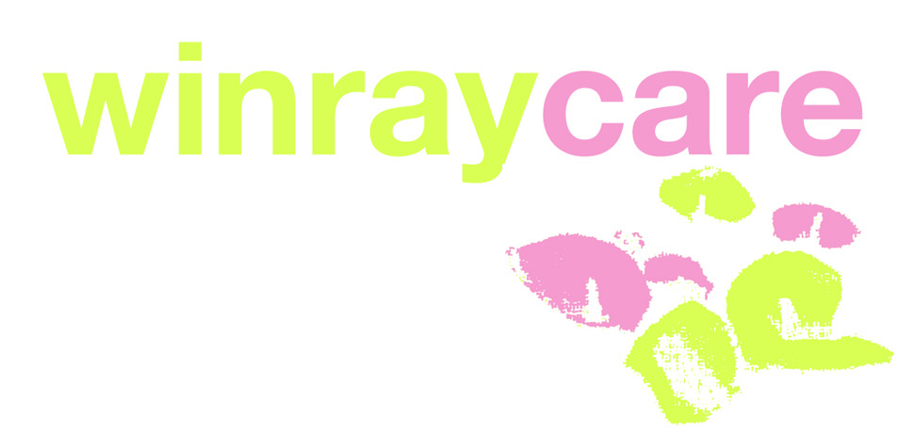
Office 13
Church Lane Chambers
11-12 Church Lane,
Leytonstone,
London E11 1HG.
Visit: www.winraycarehousing.com

WinrayCare Referral Form
(To be completed by referring agency)

PLEASE COMPLETE AND RETURN THIS FORM TO THE MANAGER AT:

Office 13
Church Lane Chambers
11-12 Church Lane,
Leytonstone,
London E11 1HG.
Tel 0208 527 8861
Email: info@winraycarehousing.com

Clients Details
Surname:

Forenames:

Current Address:

Postcode:

Telephone:

Gender:

Date of Birth:

Age:

Religion:

Legal Status:

Next of Kin:

Phone:

Address:

Other professionals involved
GP:

Tel:

Consultant:

Tel:

CPN:

Tel:

CPA Care Coordinator:

Tel:

Social Worker/ Care Manager:

Tel:

Other relevant professionals e.g. Rehab Workers (please specify)

Please attach a report on social and family history including a psychological history for Mental Health referrals. Please note referrals cannot be accepted until these are received.

Please give the reasons for your involvement with the client and what ongoing support will be offered by you or your agency during their stay at this project and for how long?

Please give a brief mental health history:

Are there any of the following health and safety issues present?
Previous attempted self harm YES NO
Previous serious self neglect YES NO
Endangered the safety of others/property YES NO
Substance abuse YES NO
Lack of health & safety awareness YES NO
Is taking medication an issue YES NO
If you answered YES to any of the above, please provide brief details here:

Are there any other health needs? E.g. epilepsy, diabetes, mobility issues:

What type of support is provided at present?
24 hour support YES NO
Part time Support YES NO
No support YES NO
Active night support YES NO
Does the client require support with:
Community Access YES NO
Personal Care YES NO
Household Tasks YES NO
Appointments YES NO
Communication YES NO
Religious & Cultural needs YES NO
Special Dietary Requirements YES NO
Other Specific needs:

What are the client’s financial arrangements?
Is there an appointee or a similar arrangement? YES NO
Is support with finances required? YES NO
Do they have any Bank/ Building Society accounts? YES NO
Do they currently pay rent? YES NO
Do they currently receive Housing Benefit? YES NO
Do they receive any other benefits? YES NO
Please provide brief details on level of financial support required:

What in your opinion is the client’s ability to make an informed choice?

What support do you feel the client will require from our service?
TELEPHONE:……………………………………….

DECLARATION
TO THE BEST OF MY KNOWLEDGE THE INFORMATION GIVEN IS CORRECT. I UNDERSTAND THAT GIVING FALSE INFORMATION TO OBTAIN A TENANCY COULD LEAD TO THIS CLIENT LOSING THEIR
TENANCY.

Signed:

Date:

Print Name:

Position:

Name of Referring Agency:

Address:

Post Code:

Telephone:

Email:

